Supporting Information

RNA-Seq analysis of mung bean (Vigna radiata L.) roots shows differential gene expression and predicts regulatory pathways responding to taxonomically different rhizobia

Sughra Hakim^{1,2}, Asma Imran¹, Muhammad Sajid Hussain³ and M. Sajjad Mirza^{1*}

*Corresponding author: Dr. M. Sajjad Mirza Tel: +92-41-9201316 ext. 268; Fax: +92-41-9201322, E-mail: sajjadmirza58@gmail.com

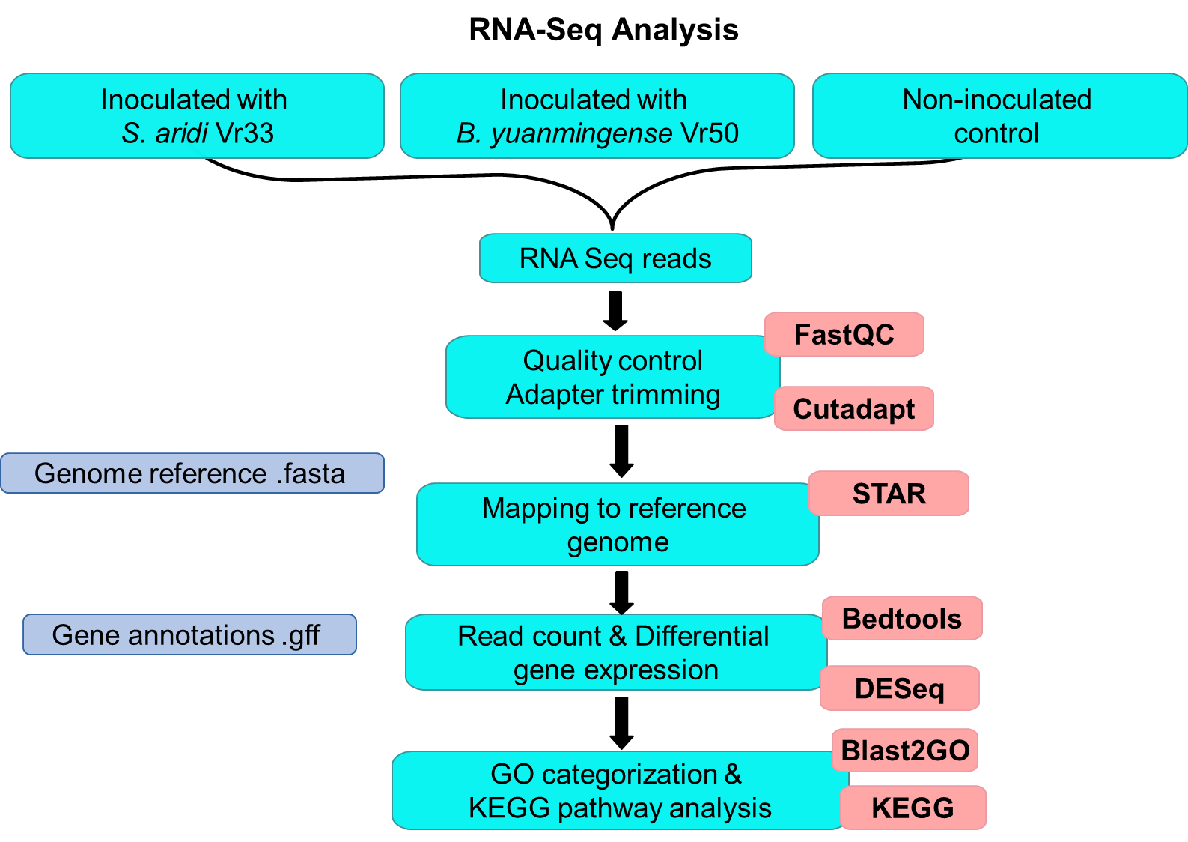

Figure S1 Flow chart showing the different steps of RNA-Seq data analysis

Table S1 Significantly enriched pathways pathway in group 1 and group 2 based on p-value (<0.05)
Pathways |  | Group 1  Sinorhizobium sp. Vr33 vs Control |  |  | Group 2  Bradyrhizobium sp. Vr50 vs Control
 |  | Up-regulated | Down-  regulated | p-value | Up-regulated | Down-regulated | p-value
1 | Metabolic pathways | 238 | 64 | 0.000385 | 326 | 178 | 4.52E-19
2 | Biosynthesis of secondary metabolites | 143 | 42 | 9.99E-07 | 181 | 118 | 5.72E-18
3 | Plant hormone signal transduction | 30 | 8 | 9.09E-05 | 31 | 34 | 0.0017
4 | Biosynthesis of amino acids | 33 | 2 | 1.66E-05 | 52 | 5 | 0.000133
5 | Phenylpropanoid biosynthesis | 20 | 15 | 0.018 | 18 | 38 | 3.35E-06
6 | Carbon metabolism | 31 | 3 | 0.0236 | 50 | 5 | 0.003396
7 | Starch and sucrose metabolism | 0 | 0 | 0 | 28 | 15 | 0.00244
8 | Cysteine and methionine metabolism | 24 | 2 | 0.049 | 31 | 7 | 6.26E-07
9 | Glycolysis / Gluconeogenesis | 16 | 2 | 0.011 | 20 | 6 | 0.00029
10 | Amino sugar and nucleotide sugar metabolism | 0 | 0 | 0 | 18 | 12 | 0.02696
11 | Pentose and glucuronate interconversions | 15 | 2 | 0.017 | 19 | 9 | 0.0211
12 | Purine metabolism | 20 | 2 | 5.72E-17 | 26 | 1 | 0.00307
12 | Carbon fixation in photosynthetic organisms | 12 | 1 | 0.041 | 19 | 4 | 7.41E-05
14 | ABC transporters | 7 | 1 | 0.00616 | 10 | 9 | 2.98E-06
15 | Alanine, aspartate and glutamate metabolism | 12 | 3 | 0.00277 | 15 | 4 | 0.00018
16 | Ubiquinone and other terpenoid-quinone biosynthesis | 11 | 3 | 0.00320 | 4 | 17 | 0.0008
17 | Pentose phosphate pathway | 11 | 2 | 0.00180 | 15 | 3 | 0.0026
18 | Flavonoid biosynthesis | - | - | - | 5 | 9 | 0.0076
19 | Tropane, piperidine and pyridine alkaloid biosynthesis | 9 | 3 | 0.02500 | 9 | 5 | 0.00238
20 | Oxocarboxylic acid metabolism | 11 | 0 | 0.02000 | - | - | -
21 | Phenylalanine, tyrosine and tryptophan biosynthesis | 10 | 0 | 0.014 | 12 | 1 | 0.0291
22 | Arginine and proline metabolism | 8 | 2 | 1.06E-17 | 0 | 0 | 0
23 | Zeatin biosynthesis | 6 | 4 | 0.02800 | 7 | 6 | 0.00155
24 | Isoflavonoid biosynthesis | 0 | 0 | 0 | 0 | 8 | 0.000289
25 | Tyrosine metabolism | 8 | 0 | 0.00540 | 0 | 0 | 0
26 | Nitrogen metabolism | 7 | 1 | 1.44E-05 | 7 | 5 | 0.012
27 | Sulfur metabolism | 8 | 1 | 0.00099 | 11 | 1 | 0.001222
28 | Carotenoid biosynthesis | 3 | 4 | 3.34E-05 | 3 | 8 | 0.03
29 | Diterpenoid biosynthesis | 0 | 0 | 0 | 3 | 8 | 0.00558
30 | Sesquiterpenoid and triterpenoid biosynthesis | 0 | 0 | 0 | 6 | 5 | 0.0042
31 | Arginine biosynthesis | 6 | 0 | 0.00060 | 10 | 0 | 0.02
32 | Steroid biosynthesis | 7 | 0 | 0.00790 | 10 | 0 | 0.008
33 | Taurine and hypotaurine metabolism | 10 | 0 | 0.00800 | 7 | 2 | 0.00042
34 | Biosynthesis of secondary metabolites - unclassified | 4 | 2 | 2.35E-07 | 4 | 0 | 0.0023
35 | Isoquinoline alkaloid biosynthesis | 6 | 0 | 0.03100 | 6 | 0 | 0.042
36 | Thiamine metabolism | 5 | 0 | 0.00046 | 5 | 0 | 0.041
37 | Biosynthesis of secondary metabolites - unclassified | 4 | 1 | 0.04700 | 0 | 0 | 0

Table S2 Protein kinases differentially expressed in Group 1 (Sinorhizobium sp. Vr33 vs. Control) and Group 2 (Bradyrhizobium sp. Vr50 vs. Control)
Gene ID in mung bean | Fold Change |  | Description
Gene ID in mung bean | Group 1 | Group 2
LOC106763732 | -1.52 | - | L-type lectin-domain containing receptor kinase IX.1-like
LOC106764612 | -1.44 | - | L-type lectin-domain containing receptor kinase IX.1-like
LOC106777698 | 1.44 | - | probable L-type lectin-domain containing receptor kinase S.5
LOC106768019 | - | 4.19 | probable LRR receptor-like protein kinase At1g35710
LOC106768739 | -1.54 | - | probable LRR receptor-like protein kinase At5g49770
LOC106768709 | 2.22 | 1.71 | probable LRR receptor-like serine/threonine-protein kinase At5g63710
LOC106773128 | 2.73 | 2.52 | probable serine/threonine-protein kinase gdt4
LOC106773565 | - | -1.40 | probable serine/threonine-protein kinase DDB_G0281745
LOC106775010 | 2.74 | 1.98 | CBL-interacting serine/threonine-protein kinase 12
LOC106775825 | - | 2.51 | receptor-like serine/threonine-protein kinase SD1-8
LOC106766263 | 1.67 | - | probable receptor-like protein kinase At5g24010
LOC106759958 | - | 2.72 | putative receptor protein kinase ZmPK1
LOC106758521 | 1.66 | 2.65 | LRK10L-2.1
LOC106758525 | 2.21 | 2.56 | LRK10L-1.4
LOC106766190 | - | 2.92 | LRK10L-1.2
LOC106753281 | -1.47 | -1.59 | cysteine-rich receptor-like protein kinase 1
LOC106761660 | - | -1.86 | phosphatidylinositol 4-phosphate 5-kinase 6
LOC106765096 | - | 1.39 | protein LYSIN MOTIF RECEPTOR KINASE LYK5
LOC106774729 | -1.33 | - | receptor-like protein kinase FERONIA
LOC106753065 | - | 1.99 | phosphatidylinositol 4-phosphate 5-kinase 1-like
LOC106777586 | - | 1.88 | probable membrane-associated kinase regulator 1

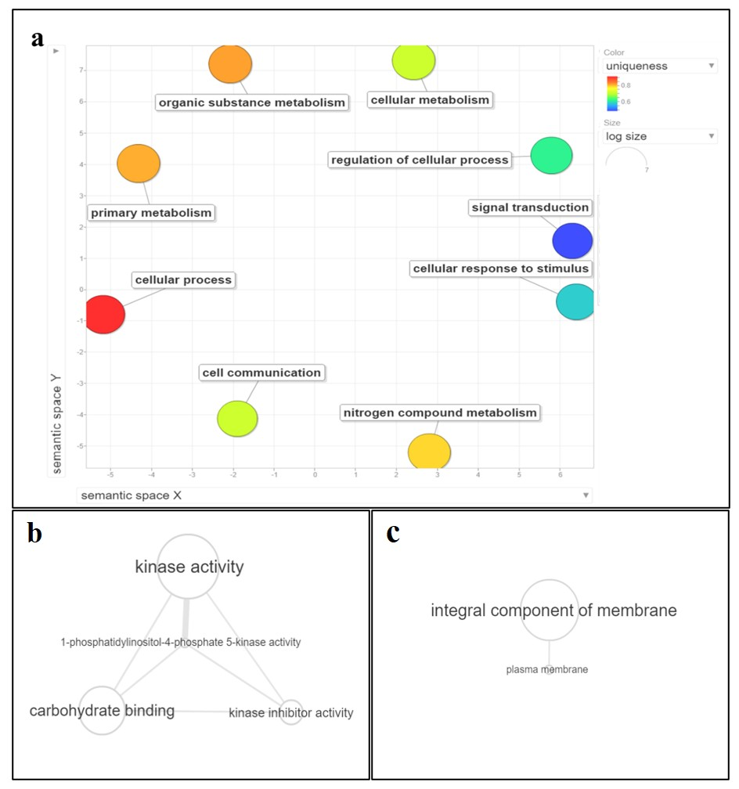
Figure S2 Functional annotation of differentially expresses protein kinases at early recognition in different GO categories i.e., (a) biological function (b) molecular function and (c) cellular components.

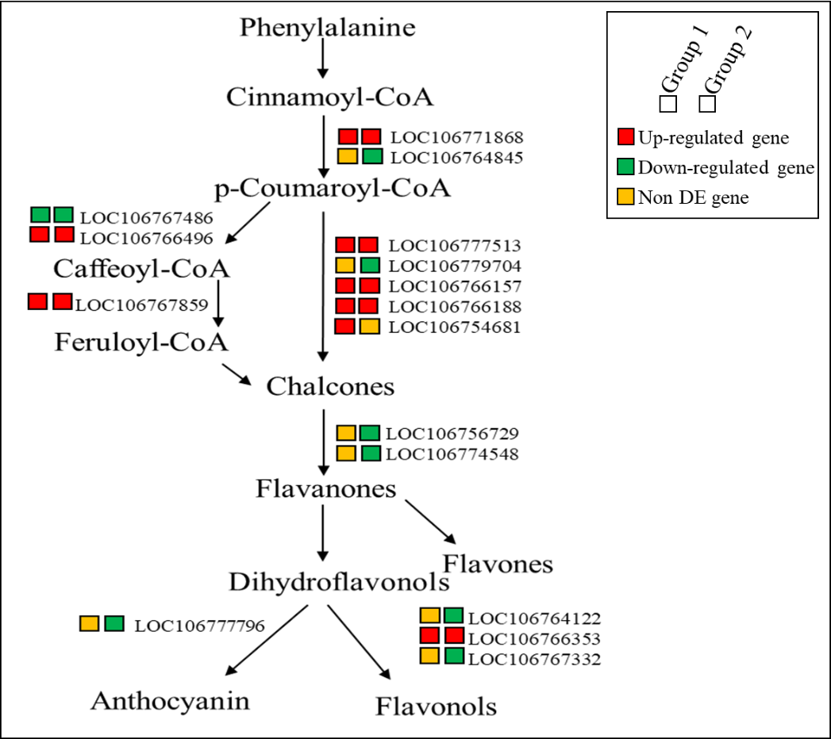
Figure S3 Differential expression ofgenesassociated with flavonoid biosynthesis pathway.
DEGs in group 1 (Sinorhizobium sp. Vr33 vs. Control) and group 2 (Bradyrhizobium sp. Vr50 vs. Control), associated with flavonoid biosynthesis pathway. Up-regulated genes are indicated by red boxes, while down-regulated genes are indicated by green boxes and non-differentially expressed genes are indicated by yellow boxes.
Table S3: The DEGs associated with ﬂavonoids biosynthesis and isoflavonoidbiosynthesis in group 1 (Sinorhizobium sp. Vr33 vs. Control) and group 2 (Bradyrhizobium sp. Vr50 vs. Control)
Gene ID in mung bean | Fold Change |  | Description
Gene ID in mung bean | Group 1 | Group 2 | Description
Flavonoid biosynthesis
LOC106777513* | 1.99 | 2.64 | chalcone synthase 17
LOC106764845 | - | -1.14 | trans-cinnamate 4-monooxygenase
LOC106771868 | 2.34 | 2.27 | cytochrome P450 CYP73A100
LOC106766157 | 4.47 | 5.13 | chalcone synthase-like
LOC106754681 | 1.13 | - | chalcone synthase 17-like
LOC106766188 | 5.90 | 6.67 | chalcone synthase-like
LOC106779704 | 0.00 | -1.18 | chalcone synthase 17-like
LOC106767486 | -1.97 | -2.39 | salutaridinol 7-O-acetyltransferase
LOC106766496 | 6.16 | 7.52 | spermidine hydroxycinnamoyl transferase
LOC106767859 | 2.35 | 2.34 | caffeoyl-CoA O-methyltransferase At4g26220
LOC106756729 | - | -1.72 | flavonoid 3'-monooxygenase
LOC106774548 | 0.00 | -1.80 | flavonoid 3'
LOC106764122 | - | -2.00 | dihydroflavonol 4-reductase-like
LOC106766353 | 1.98 | 3.15 | anthocyanidin reductase ((2S)-flavan-3-ol-forming)
LOC106767332 | - | -1.18 | anthocyanidin reductase ((2S)-flavan-3-ol-forming)-like
LOC106777796 | 0.00 | -2.04 | leucoanthocyanidin dioxygenase
LOC106767069 | - | -1.35 | caffeoyl-CoA O-methyltransferase 5
LOC106760643 | - | -1.17 | UDP-glycosyltransferase 88F5-like
Isoflavonoid biosynthesis
LOC106760053* | - | 1.60 | isoflavone 2'-hydroxylase
LOC106773682* | - | -3.13 | cytochrome P450 81E8-like
LOC106756257 | - | -1.25 | isoflavone reductase-like protein
LOC106756258 | - | -1.11 | isoflavone reductase homolog
LOC106758582 | - | -1.34 | isoflavone 7-O-methyltransferase-like
LOC106759051 | - | -2.38 | isoflavone 7-O-methyltransferase-like
LOC106759056 | -1.37 | -1.36 | isoflavone 7-O-methyltransferase-like
LOC106759715 | - | -1.22 | isoflavone 2'-hydroxylase
LOC106761763 | - | -1.44 | isoflavone 2'-hydroxylase-like
LOC106766214 | -1.46 | -1.48 | isoflavone 3'-hydroxylase
LOC106771418 | -1.24 | -1.71 | isoflavone 7-O-methyltransferase-like
LOC106774974 | - | -1.56 | cytochrome P450 81E8
LOC106780380 | - | -2.33 | isoflavone 4'-O-methyltransferase
LOC111241498 | - | -1.57 | isoflavone 7-O-methyltransferase-like
*DEGs expressed at early growth stage (1-3 hpi)

Table S4 The DEGs associated with plant hormone signal transduction pathway in group 1 (Sinorhizobium sp. Vr33 vs. Control) and group 2 (Bradyrhizobium sp. Vr50 vs. Control)
Gene ID in mung bean | Fold Change |  | Description
Gene ID in mung bean | Group 1 | Group 2
LOC106761693 | - | 2.41 | abscisic acid receptor PYL2-like
LOC106770900 | - | -1.56 | abscisic acid receptor PYL4-like
LOC106776425 | -1.17 | -1.24 | abscisic acid receptor PYR1
LOC106767322 | - | -1.46 | abscisic acid receptor PYR1-like
LOC106776141 | - | -1.13 | auxin response factor 3
LOC106780009 | - | -1.00 | auxin response factor 9
LOC106765013 | - | -1.11 | auxin transporter-like protein 1
LOC106772219 | - | -1.27 | auxin transporter-like protein 2
LOC106759643 | - | -1.52 | auxin transporter-like protein 3
LOC106774103 | - | -1.26 | auxin transporter-like protein 4
LOC106762262 | 1.10 | - | auxin-induced protein 10A5-like
LOC106762263 | 1.90 | 1.54 | auxin-induced protein 15A
LOC106767633 | - | -1.86 | auxin-induced protein 6B
LOC106757571 | 1.83 | 2.59 | auxin-induced protein AUX28-like
LOC106772359 | - | -1.28 | auxin-responsive protein IAA16
LOC106761359 | 1.12 | 1.27 | auxin-responsive protein IAA17
LOC106762490 | - | -1.21 | auxin-responsive protein IAA26
LOC106774072 | - | -1.20 | auxin-responsive protein IAA27
LOC106761476 | - | -1.36 | auxin-responsive protein IAA29
LOC106767796 | 3.18 | 4.31 | auxin-responsive protein IAA31
LOC106757523 | 1.60 | 1.13 | auxin-responsive protein SAUR15
LOC106761400 | 2.12 | 2.48 | auxin-responsive protein SAUR21
LOC106761547 | - | 1.87 | auxin-responsive protein SAUR23-like
LOC106780333 | -1.13 | 0.00 | auxin-responsive protein SAUR32
LOC106754022 | -1.13 | -1.55 | auxin-responsive protein SAUR32-like
LOC106758641 | -1.32 | -1.37 | auxin-responsive protein SAUR36
LOC106773634 | - | -1.02 | auxin-responsive protein SAUR36-like
LOC106761365 | 3.21 | 4.68 | auxin-responsive protein SAUR50
LOC106780526 | - | 1.67 | auxin-responsive protein SAUR50
LOC106764511 | - | -2.07 | auxin-responsive protein SAUR50
LOC106761700 | 1.33 | 2.27 | auxin-responsive protein SAUR71
LOC106761492 | -1.42 | -1.54 | auxin-responsive protein SAUR71
LOC106761123 | - | 1.23 | BRI1 kinase inhibitor 1
LOC106757344 | - | -1.93 | bZIP transcription factor TGA10
LOC106765080 | - | -1.12 | coronatine-insensitive protein 1
LOC106765652 | 1.38 | 1.85 | cyclin-D3-2
LOC106777141 | - | -1.20 | cyclin-D3-2
LOC106760831 | - | 1.14 | cyclin-D3-3
LOC106754827 | - | -1.05 | DELLA protein GAI1
LOC106771073 | - | -1.33 | ethylene-responsive transcription factor 1B
LOC106770299 | - | -1.86 | ethylene-responsive transcription factor 1B-like
LOC106757833 | - | -1.03 | gibberellin receptor GID1B
LOC106773969 | 1.84 | 2.31 | histidine-containing phosphotransfer protein 1
LOC106776860 | - | -1.56 | indole-3-acetic acid-amido synthetase GH3.10-like
LOC106757056 | 2.07 | 3.13 | indole-3-acetic acid-amido synthetase GH3.4
LOC106780027 | - | 1.59 | indole-3-acetic acid-amido synthetase GH3.6
LOC106756430 | -1.50 | -1.72 | indole-3-acetic acid-amido synthetase GH3.6
LOC106777251 | 2.50 | 3.92 | probable indole-3-acetic acid-amido synthetase GH3.1
LOC106776303 | 1.69 | - | probable indole-3-acetic acid-amido synthetase GH3.1
LOC106762131 | - | -1.15 | probable protein phosphatase 2C 53
LOC106766748 | 1.40 | 1.58 | probable xyloglucan endotransglucosylase/hydrolase protein 23
LOC106768744 | 1.36 | - | probable xyloglucan endotransglucosylase/hydrolase protein 23
LOC106762247 | -2.04 | - | probable xyloglucan endotransglucosylase/hydrolase protein 23
LOC106756003 | - | 1.59 | protein TIFY 6B
LOC106776925 | - | -1.13 | protein TIFY 6B
LOC106767080 | 1.58 | - | protein TIFY 10A
LOC106773006 | 1.26 | - | protein TIFY 10A
LOC106759829 | 1.23 | - | protein TIFY 10B
LOC106777895 | 2.32 | - | protein TIFY 10B-like
LOC106752584 | 2.39 | 3.51 | regulatory protein NPR5
LOC106772605 | - | 3.20 | regulatory protein NPR5
LOC106766451 | 7.00 | 8.13 | serine/threonine-protein kinase SRK2A
LOC106776863 | 3.16 | 4.31 | transcription factor TGA2.2
LOC106752566 | - | -1.06 | transcription factor TGA2.3
LOC106780589 | -1.16 | -1.64 | transcription factor TGA7
LOC106754080 | - | -1.07 | transcription factor TGA9
LOC106766891 | - | -1.02 | two-component response regulator ARR17
LOC106767155 | -1.22 | - | two-component response regulator ARR5
LOC106760963 | - | 1.39 | two-component response regulator ARR5
LOC106779256 | 2.15 | 2.32 | two-component response regulator ARR8
LOC106752532 | 0.00 | 1.28 | two-component response regulator ARR9
LOC106761196 | 2.84 | 3.99 | two-component response regulator ORR10
LOC106760951 | 1.11 | 1.41 | two-component response regulator ORR10
LOC106768890 | - | 1.59 | xyloglucan endotransglucosylase/hydrolase protein 22
LOC106768904 | 2.46 | - | xyloglucan endotransglucosylase/hydrolase protein 22

Table S5 Differentially expressed nodulin genes identiﬁed in mung bean roots by RNA-Seq
Gene name | Gene ID in mung bean | Fold Change
Gene name | Gene ID in mung bean | Group 1 | Group 2
Nodulin-related protein 1 | LOC106767550 | -1.31 | -1.24
Early nodulin-like protein 2 | LOC106755384 | 3.39 | 3.74
Early nodulin-like protein 3 | LOC106778557 | - | -1.81
Early nodulin-like protein 3 | LOC106775534 | 1.60 | 2.32
Early nodulin-like protein 3 | LOC106755743 | - | -1.35
Nodulin-21-like | LOC106752798 | 9.78 | 10.96
Nodulin-26 | LOC106779799 | 2.35 | 4.75
Nodulin-26 | LOC106775040 | -2.24 | -2.36
Nodulin-30-like | LOC106760593 | 11.43 | 13.15
Nodulin-30-like | LOC106760526 | 11.28 | 13.01
Nodulin-C51-like | LOC111241587 | 1.41 | 2.21
Early nodulin-55-2 | LOC106768033 | 7.89 | 9.20
Early nodulin-70 | LOC106753456 | 7.42 | 8.72
Early nodulin-75-like | LOC106764346 | -5.85 | -4.66
Early nodulin-93 | LOC106767688 | 4.26 | 2.94
Early nodulin-93-like | LOC106767689 | 6.93 | 6.13
Early nodulin-93-like | LOC106757047 | 11.04 | 11.77
Leghemoglobin-1-like | LOC106770606 | 10.90 | 12.02
Leghemoglobin-2 | LOC106771851 | 12.07 | 13.47
Leghemoglobin-2-like | LOC106771163 | 12.16 | 13.35
Leghemoglobin-like | LOC106771420 | 10.36 | 11.53

